“FORM 1  THE PATENTS ACT 1970 (39 of 1970) and  THE PATENTS RULES, 2003  APPLICATION FOR GRANT OF PATENT  (See section 7, 54 and 135 and sub-rule (1) of rule 20) |  |  |  |  |  |  |  |  |  |  |  |  |  | (FOR OFFICE USE ONLY)
 |  |  |  |  |  | Application No.
 |  |  |  |  |  | Filing date:
 |  |  |  |  |  | Amount of Fee paid:
 |  |  |  |  |  | CBR No:
 |  |  |  |  |  | Signature:
1. APPLICANT’S REFERENCE / IDENTIFICATION NO. (AS ALLOTTED BY OFFICE)
2. TYPE OF APPLICATION *Please tick (ü ) at the appropriate category+
Ordinary (ü) |  |  |  |  |  | Convention ( ) |  |  |  |  |  |  |  |  |  | PCT-NP ( ) |  |  |  |  | PPH ( )
Divisional  ( ) |  | Patent of  Addition ( ) |  |  |  | Divisional  ( ) |  |  |  |  | Patent of  Addition ( ) |  |  |  |  | Divisional  ( ) |  |  |  | Patent of  Addition ( )
3A. APPLICANT(S)
Name in Full |  |  | Gender |  | Nationality |  |  | Country of Residence |  |  |  | Age (optional,  for natural  persons) |  |  | Address of the Applicant
SNS College of Technology |  |  | NA |  | Indian |  |  | India |  |  |  | NA |  |  | House No. |  |  | SNS Kalvi Nagar, Sathy Main Road, NH-209, Vazhiyampalayam, Saravanampatti, Coimbatore – 641035, Tamilnadu, India
 |  |  |  |  |  |  |  |  |  |  |  |  |  |  | Street
 |  |  |  |  |  |  |  |  |  |  |  |  |  |  | City
 |  |  |  |  |  |  |  |  |  |  |  |  |  |  | State
 |  |  |  |  |  |  |  |  |  |  |  |  |  |  | Country
 |  |  |  |  |  |  |  |  |  |  |  |  |  |  | Pin code
 |  |  |  |  |  |  |  |  |  |  |  |  |  |  | Email |  |  | sivaram0699@gmail.com
 |  |  |  |  |  |  |  |  |  |  |  |  |  |  | Contact No |  |  | +91 96295 73042
3B. CATEGORY OF APPLICANT *Please tick (ü) at the appropriate category+
Natural Person ( ) |  |  |  |  |  | Other than Natural Person (ü)
 |  |  |  |  |  | Small Entity ( ) |  |  |  | Startup ( ) |  |  |  |  | Others ( ) |  |  |  |  | Educational Institute (ü)
4. INVENTOR(S) *Please tick (ü) at the appropriate category+
Are all the inventor(s)  same as the applicant(s)  named above? |  |  |  |  |  | Yes ( ) |  |  |  |  |  |  |  |  |  | No (ü)
If “No”, furnish the details of the inventor(s)
Name in Full |  |  | Gender |  | Nationality |  |  | Age |  |  | Country of Residence |  |  |  | Address of the Inventor
POORNA DEVI M |  |  | Female |  | Indian |  |  | 20 |  |  | India |  |  |  | House No. |  |  | Dept of CSE(IoT), SNS College of Technology, SNS Kalvi Nagar, Sathy Main Road, NH-209, Vazhiyampalayam, Saravanampatti, Coimbatore – 641035, Tamilnadu, India
 |  |  |  |  |  |  |  |  |  |  |  |  |  |  | Street
 |  |  |  |  |  |  |  |  |  |  |  |  |  |  | City
 |  |  |  |  |  |  |  |  |  |  |  |  |  |  | State
 |  |  |  |  |  |  |  |  |  |  |  |  |  |  | Country
 |  |  |  |  |  |  |  |  |  |  |  |  |  |  | Pin code
 |  |  |  |  |  |  |  |  |  |  |  |  |  |  | Email |  |  | poornadevi.m.iot.2023@snsce.ac.in
 |  |  |  |  |  |  |  |  |  |  |  |  |  |  | Contact No |  |  | +91 9342568524
KANTHIMATHINATHAN P |  |  | Male |  | Indian |  |  | 19 |  |  | India |  |  |  | House No. |  |  | Dept of CSE(IoT), SNS College of Technology, SNS Kalvi Nagar, Sathy Main Road, NH-209, Vazhiyampalayam, Saravanampatti, Coimbatore – 641035, Tamilnadu, India
 |  |  |  |  |  |  |  |  |  |  |  |  |  |  | Street
 |  |  |  |  |  |  |  |  |  |  |  |  |  |  | City
 |  |  |  |  |  |  |  |  |  |  |  |  |  |  | State
 |  |  |  |  |  |  |  |  |  |  |  |  |  |  | Country
 |  |  |  |  |  |  |  |  |  |  |  |  |  |  | Pin code
 |  |  |  |  |  |  |  |  |  |  |  |  |  |  | Email |  |  | kanthimathinathan.p.iot.2023@snsce.ac.in
 |  |  |  |  |  |  |  |  |  |  |  |  |  |  | Contact No |  |  | +91 6383349601
AJUVAITHA K |  |  | Female |  | Indian |  |  | 20 |  |  | India |  |  |  | House No. |  |  | Dept of CSE(IoT), SNS College of Technology, SNS Kalvi Nagar, Sathy Main Road, NH-209, Vazhiyampalayam, Saravanampatti, Coimbatore – 641035, Tamilnadu, India
 |  |  |  |  |  |  |  |  |  |  |  |  |  |  | Street
 |  |  |  |  |  |  |  |  |  |  |  |  |  |  | City
 |  |  |  |  |  |  |  |  |  |  |  |  |  |  | State
 |  |  |  |  |  |  |  |  |  |  |  |  |  |  | Country
 |  |  |  |  |  |  |  |  |  |  |  |  |  |  | Pin code
 |  |  |  |  |  |  |  |  |  |  |  |  |  |  | Email |  |  | ajuvaitha.k.iot.2023@snsce.ac.in
 |  |  |  |  |  |  |  |  |  |  |  |  |  |  | Contact No |  |  | +91 7373787243
5. TITLE OF THE INVENTION:
A Quantum ML Simulation and Hardware Deployment Platform
6. AUTHORISED REGISTERED PATENT  AGENT(S) |  |  |  |  |  | IN/PA No.
 |  |  |  |  |  | Name
 |  |  |  |  |  | Mobile No.
7. ADDRESS FOR SERVICE OF APPLICANT IN INDIA |  |  |  |  |  | Name |  |  |  |  |  |  |  |  |  | Dr. Husna Khouser G
 |  |  |  |  |  | Postal Address |  |  |  |  |  |  |  |  |  | Assistant Professor, Department of Electronics and Communication, SNS College of Technology, SNS Kalvi Nagar, Sathy Main Road, NH-209, Vazhiyampalayam, Saravanampatti, Coimbatore – 641035, Tamilnadu, India
 |  |  |  |  |  | Telephone No. |  |  |  |  |  |  |  |  |  | -
 |  |  |  |  |  | Mobile No. |  |  |  |  |  |  |  |  |  | +91 6380232559
 |  |  |  |  |  | Fax No. |  |  |  |  |  |  |  |  |  | -
 |  |  |  |  |  | E-mail ID |  |  |  |  |  |  |  |  |  | husnaece17@gmail.com
8. IN CASE OF APPLICATION CLAIMING PRIORITY OF APPLICATION FILED IN CONVENTION COUNTRY, PARTICULARS OF CONVENTION APPLICATION:
Country | Application  Number |  |  | Filing date |  |  | Name of the  Applicant |  |  |  | Title of the invention |  |  |  |  |  | IPC (as classified in the convention country)
Not Applicable
9. IN CASE OF PCT NATIONAL PHASE APPLICATION, PARTICULARS OF INTERNATIONAL APPLICATION FILED UNDER PATENT CO-OPERATION TREATY (PCT):
International application number |  |  |  |  |  |  |  |  |  |  |  |  |  | International filing date
Not Applicable
10. IN CASE OF DIVISIONAL APPLICATION FILED UNDER SECTION 16, PARTICULARS OF ORIGINAL (FIRST) APPLICATION
Original (first) application No |  |  |  |  |  |  |  |  |  |  |  |  |  | Date of filing of original (first) application
Not Applicable
11. IN CASE OF A PATENT OF ADDITION FILED UNDER SECTION 54, PARTICULARS OF MAIN APPLICATION OR PATENT
Main application/patent No. |  |  |  |  |  |  |  |  |  |  |  |  |  | Date of filing of main application
Not Applicable
12. DECLARATIONS
(i) Declaration by the inventor(s)-
(In case the applicant is an assignee: the inventor(s) may sign herein below or the applicant may upload the assignment or enclose the assignment with this application for patent or send the assignment by post/electronic transmission duly authenticated within the prescribed period).

I/We, the above-named inventor(s) is/are the true & first inventor(s) for this Invention and declare that the applicant(s) herein is/are my/our assignee or legal representative.

i) | (a) Date:  (b) Signature: (c) Name: | 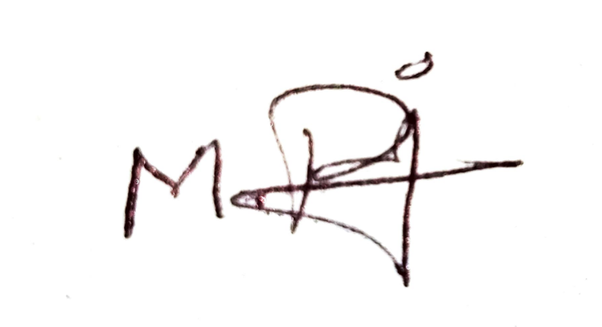17/02/2026  POORNA DEVI M
ii) | (a) Date:  (b) Signature: (c) Name: | 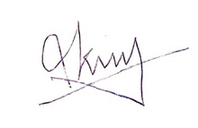17/02/2026  KANTHIMATHINATHAN P
iii) | (a) Date:  (b) Signature: (c) Name: | 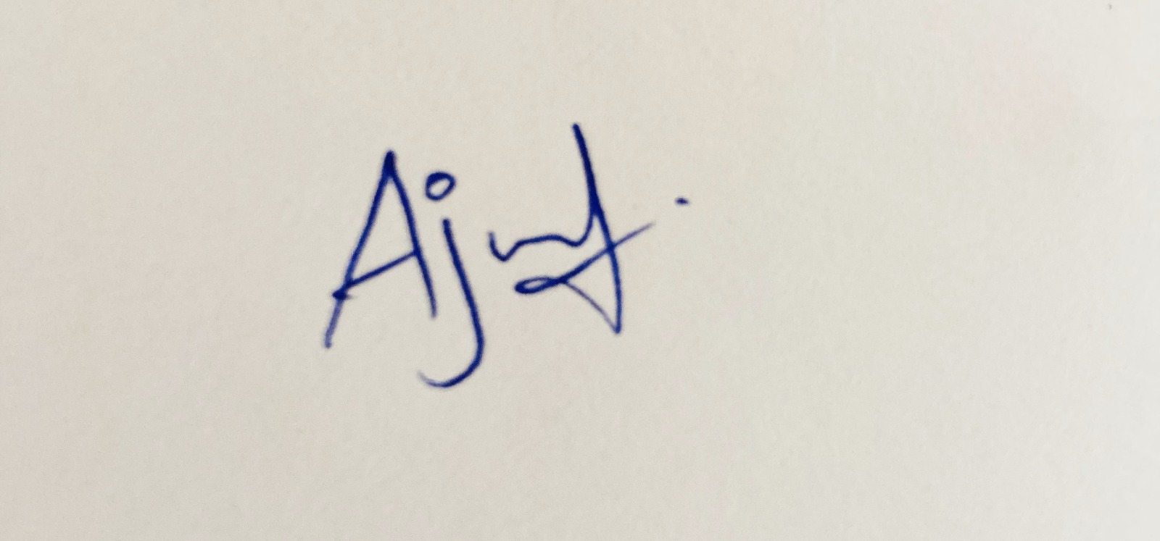17/02/2026  ARUL MURUGAN R

ii) Declaration by the applicant(s) in the convention country
(In case the applicant in India is different than the applicant in the convention country: the applicant in the convention country may sign herein below or applicant in India may upload the assignment from the applicant in the convention country or enclose the said assignment with this application for patent or send the assignment by post/electronic transmission duly authenticated within the prescribed period)
I/We, the applicant(s) in the convention country declare that the applicant(s) herein is/are my/our assignee or legal representative.
(a) Date
(b) Signature(s)
(c) Name(s)
(iii) Declaration by the applicant(s)
(ü) I am / We are in possession of the above-mentioned invention.
(ü) The provisional/complete specification relating to the invention is filed with this application.
( ) The invention as disclosed in the specification uses the biological material from India and the necessary permission from the competent authority shall be submitted by me/us before the grant of patent to me/us.
(ü) There is no lawful ground of objection(s) to the grant of the Patent to me/us.
(ü) I am/we are the true & first inventor(s).
(ü) I am/we are the assignee or legal representative of true & first inventor(s).
( ) The application or each of the applications, particulars of which are given in Paragraph-8, was the first application in convention country/countries in respect of my/our invention(s).
( ) I/We claim the priority from the above-mentioned application(s) filed in convention country/countries and state that no application for protection in respect of the invention had been made in a convention country before that date by me/us or by any person from which I/We derive the title.
( ) My/our application in India is based on international application under Patent Cooperation Treaty (PCT) as mentioned in Paragraph-9.
( ) The application is divided out of my /our application particulars of which is given in Paragraph-10 and pray that this application may be treated as deemed to have been filed on DD/MM/YYYY under section 16 of the Act.
( ) The said invention is an improvement in or modification of the invention particulars of which are given in Paragraph-11.
13. FOLLOWING ARE THE ATTACHMENTS WITH THE APPLICATION
(a) Form 2
Item |  |  |  |  |  | Details |  |  |  |  |  |  | Fee |  |  |  |  |  | Remarks
Complete/Provisional specification) # |  |  |  |  |  | No. of Pages |  |  | - 05 |  |  |  |  |  |  |  |  |  | Complete Specification  Total No of Pages: 9
No. of Claim(s) |  |  |  |  |  | No. of Claims  No. of pages |  |  | - 08  - 02
Abstract |  |  |  |  |  | No. of pages |  |  | - 01
No. of Drawing(s) |  |  |  |  |  | No. of drawings  No. of Pages |  |  | - 01  - 01
# In case of a complete specification, if the applicant desires to adopt the drawings filed with his provisional specification as the drawings or part of the drawings for the complete specification under rule 13(4), the number of such pages filed with the provisional specification are required to be mentioned here
(b) Complete specification (in conformation with the international application)/as amended before the International Preliminary Examination Authority (IPEA), as applicable (2 copies).
(c) Sequence listing in electronic form
(d) Drawings (in conformation with the international application)/as amended before the International Preliminary Examination Authority (IPEA), as applicable (2 copies).
(e) Priority document(s) or a request to retrieve the priority document(s) from DAS (Digital Access Service) if the applicant had already requested the office of first filing to make the priority document(s) available to DAS.
(f) Translation of priority document/Specification/International Search Report/International Preliminary Report on Patentability.
(g) Statement and Undertaking on Form 3
(h) Declaration of Inventorship on Form 5
(i) Power of Authority (J)…………………………………………………………………………………………………..

I/We hereby declare that to the best of my/our knowledge, information and belief the fact and matters stated herein are correct and I/We request that a patent may be granted to me/us for the said invention.

Dated this ____day of February 2026.

To
The Controller of Patents
The Patent Office, at Chennai/Mumbai/Delhi/Kolkata

Note: -
* Repeat boxes in case of more than one entry.
* To be signed by the applicant(s) or by authorized registered patent agent otherwise where mentioned
* Tick ()/cross (x) whichever is applicable/not applicable in declaration in paragraph-12.
* Name of the inventor and applicant should be given in full, family name in the beginning.
* Strike out the portion which is/are not applicable.
* For fee: See First Schedule”

